
SCHOOL OF COMPUTER SCIENCE AND ENGINEERING

Academic Year 2022-23

INTERNSHIP REPORT
On
Data Science and Machine Learning
Submitted in partial fulfilment of academic session in under graduate program of
BACHELOR OF TECHNOLOGY
In
COMPUTER SCIENCE ENGINEERING-DATA SCIENCE

Submitted by

Prabal Dhar
21BTRCD056

Under the guidance of

GUIDE NAME
Designation
School of Computer Science Engineering-Branch name
Faculty of Engineering & Technology
JAIN (Deemed-to-be UNIVERSITY)
DEPARTMENT OF COMPUTER SCIENCE ENGINEERING-
SOFTWARE ENGINEERING

CERTIFICATE
This is to certify that the “Internship report” submitted by Prabal Dhar(USN:
21BTRCD056) is the work done by he/her and submitted during 2022 – 2023 academic year, in partial fulfilment of the requirements for the award of the degree of Bachelor of Technology in Computer Science Engineering-Software Engineering, Faculty of Engineering & Technology, JAIN (Deemed-to-be University) , at Company name

Internal Guide Name | Internship Coordinator Name
Department of Computer Science Engineering-Data Science ,  Faculty of Engineering & Technology,  JAIN (Deemed-to-be University)  Date: | Department of Computer Science Engineering- Data Science ,  Faculty of Engineering & Technology,  JAIN (Deemed-to-be University)  Date:
Dr. Ramesh S
Department of Computer Science Engineering- Data Science ,
Faculty of Engineering & Technology,
JAIN (Deemed-to-be University)
Date:

Internship Completion Certificate from Company

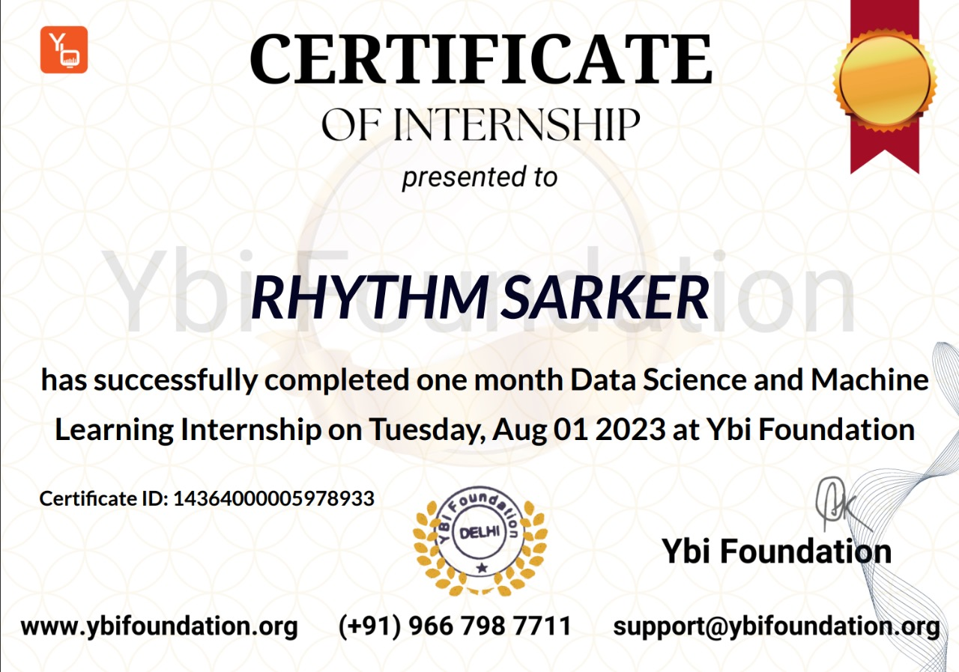

ACKNOWLEDGEMENT
It is a great pleasure for us to acknowledge the assistance and support of a large number of individuals who have been responsible for the successful completion of this project work.
First, we take this opportunity to express our sincere gratitude to Faculty of Engineering & Technology, JAIN (Deemed-to-be University) for providing us with a great opportunity to pursue our Bachelor’s Degree in this institution.
In particular we would like to thank Dr. Geetha G., Director, School of Computer Science Engineering, JAIN (Deemed to be UNIVERSITY) for her constant encouragement and expert advice.
It is a matter of immense pleasure to express our sincere thanks to Dr. Chandramma R, Program, Department, Department of Computer Science Engineering-Software Engineering, JAIN (Deemed-to-be University), for providing right academic guidance that made our task possible.
We would like to thank our guide Guide Name, Assistant/Associate Professor, Department of Computer Science Engineering-Software Engineering, JAIN (Deemed-to-be University), for sparing his valuable time to extend help in every step of our project work, which paved the way for smooth progress and fruitful culmination of the project.
We would like to thank our Internship Coordinator N.Shantha kumar and all the staff members of Software Engineering Department for their support.
We are also grateful to our family and friends who provided us with every requirement throughout the course.
We would like to thank one and all who directly or indirectly helped us in completing the project work successfully.

Signature of Students

TABLE OF CONTENTS

Description |  | Page No
 | Acknowledgement
 | Introduction
 | Company Information
 | Internship Description
 | Main Content / Process in Industry
 | Description of Internship Experience
 | Weekly Report
 | Conclusion

CHAPTER 1:
INTRODUCTION

The Data Science and Machine Learning using the Python to acquire, clean, and analyze the data using the powerful machine learning model and python libraries.

In this internship, I was introduced to the Google Colab, I learned about the data science and the concepts of machine learning model. How to use the machine learning model in the data science field as well as types of the machine learning. I was introduced to the machine learning models and select the best model of machine learning for the data science problems. I solved the basic problems of data science using the machine learning models. I also completed the one major project, the project title is Women Cloth Reviews Prediction with Multi Nominal Naive Bayes.

CHAPTER 2:
COMPANY INFORMATION

Ybi Foundation is a Delhi-based not-for-profit edutech company that aims to enable the youth to grow in the world of emerging technologies. They offer a mix of online and offline approaches to bring new skills, education, technologies for students, academicians and practitioners. They believe in the learning anywhere and anytime approach to reach out to learners. The platform provides free online instructor-led classes for students to excel in data science, business analytics, machine learning, cloud computing and big data. They aim to focus on innovation, creativity, technology approach and keep themselves in sync with the present industry requirements. They endeavor to support learners to achieve the highest possible goals in their academics and professions.
Legal Name : YBI Foundation
Headquarters : Delhi, Delhi, India
Business Model : B2C
Founding Date : Oct 2020
No. of Employees : <10
Core Team : 1. Alok Yadav Dr Co-Founder
2. Arushi Co-Founder

Students of Engineering, Management, Computer Application and one's interested to make career in emerging technologies like machine learning, AI, big data, cloud computing, data science etc.
User Age : Less than 18, 18 to 25, 26 to 34
User Income : Lower income, Lower-middle Income, Upper middle Income, High Income
Location :India, India Tier 1, India Tier 2, India Tier 3, Global, Asia Pacific, Europe, North America, South America, Africa
Contact :support@ybifoundation.org WhatsApp (+91) 9667987711
Read more at: https://yourstory.com/companies/ybi-foundation

CHAPTER 3:
INTERNSHIP DESCRIPTION

The data science and machine learning internship is provided by ybi foundation. It’s a free internship program at four weeks that means the internship program duration is one month. The tile is data science and machine learning internship and this internship only for computer science engineering students. An internship is a professional learning experience that offers meaningful, practical work related to a student’s field of study or career interest. An internship gives a student the opportunity for career exploration and development, and to learn new skills.

Objectives of Internship:
- Introduction to internship
- Scope of Data Science
- Introduction to Google Colab
- Introduction to Python
- Import Dataset
- Data Wrangling
- Data Exploratory
- Read Data as DataFrame
- Explore DataFrame
- Introduction to Machine Learning
- Python Libraries for Data Science and Machine Learning
Using the above following things, the dataset is prepared for the machine learning model.
- Select the Feature and Target from Dataset
- Select the Best Machine Learning Model for Problem
- Model Fit
- Model Predict
- Model Evaluation

CHALLENGES OF INTERNSHIP:

1. Understanding the Problems
2. Understanding the machine learning concepts
3. Model Selection
4. Non-Cooperative Seniors
5. Time Management

CHAPTER 4:
MAIN CONTENT / PROCESS IN INDUSTRY

The main content is data science problems solving using the python libraries and machine learning model. Understanding the machine learning concepts, and applying that problems. In the sample machine learning model there are 8 (eight) concepts following below:

Step 01:
- Import Python Library
Step 02:
- Import Dataset(data frame)
- Read Dataset

Step 03:

Define target(y) and feature(x)
Step 04:
- Train-Test-Split
Step 05:
- Ordinary Least Square(OLS) also called as 'Select Model
Step 06:
- Train model(Fit model)
Step 07:
- Model Prediction
Step 08:
- Accuracy of the model -- Return the error values

Following the above things I learned how to applied machine learning models for relevant problems. The well-known and widely used industry that can help data science and machine learning projects.
In the industry field the data science and machine learning project into six (6) iterative steps following below:

01. Business Understanding:
- This involves understanding problem statement and target user
- What we are solving and why it matters
- Understanding the how problem is solved today
02. Data Understanding:
- Gathering data, data validation, data Relationships
- performing exploratory data analysis
- Performing statistical analysis and visualizations, identifying any patterns, and dimensionality reduction.
03. Data Preparation:
- Involves data feature engineering and selection that will get data prepped for modeling.
- The steps that will get your data prepped for modeling.
- Dataset scaling, standardizing, and splitting data into training and test set.
- Optionally encoding categorical features.

04. Modeling:
- Modeling involves both model selection and tuning.
- Selecting the best model for that problems
- The modelling process involves evaluating various algorithms
- Linear Regression
- Statistical Classification
- Logistic Regression
- Random Forest
- Naïve Bayes Classifier
05. Evaluation:
- Model performance
- Accuracy Score
- Confusion Metris
- Classification Report
- Mean Squared Error and Mean Absolute Error
06. Deployment:
- Model Deploy
- Rolling
- Deploy in Place
- Traffic Splitting
CHAPTER 5:
DESCRIPTION OF INTERNSHIP EXPERIENCE:
I have taken an internship from ybi foundation at data science and machine learning. Form 04-07-2023 to 02-08-23 one month internship sir, Alok Yadav taken the internship classes. Mr. Alok Yadav class explanation is very good. I easily understood that class, after class sir given the homework for that related task. Day by day I learned new things through that internship. Had trouble understanding the first few classes, and understanding data science scope, and also machine learning concepts but I am glad that I was able to complete all things properly.

I completed many data science and machine learning projects like cancer detection, diabetes prediction, etc through that projects I learned how to prepared dataset for projects and data science problems. How to select the best machine learning model for that problem. Projects management, and team management. I achieved new skills and method such as python libraries, and classification and regression problem solving.
I enjoyed that internship. This internship experience will be supported to me in academic projects, job sector, and my professional sector.

CHAPTER 6:
WEEKLY REPORT

DATE | Week No. | NAME OF THE TOPIC/MODULE COMPLETED
First Week  04-07-23 To 11-07-23 | 01 | - Introduction to Internship  - Introduction to Python  - Introduction to Google Colab  - Introduction to Dataset  - Introduction to Data Analyze
Second Week  12-07-23 To 18-07-23 | 02 | - Introduction to Machine learning  - Types of Machine Learning  - Understanding to Problems  - Apply the Machine Learning Steps  - Select the Machine Learning Model
Third Week  19-07-23 To 25-07-23 | 03 | - Introduction to Project  - How to build the Project  - Understanding to the Project Problem  - Completed the Sample Project  - Diabetes prediction
Third Week  26-07-23 To 02-08-23 | 04 | - Completed the Minor Projects  - Cancer Prediction  - Chance admission prediction  - Purchase Prediction  - Credit Card Default Prediction  - Explanation to major project  - Select to the major Project for Internship  - After that, Project Submission  - Final Quiz Exam

CHAPTER 7:
CONCLUSION
Using the google colab, dataset import, read, clean, and describe. The dataset prepped for the machine learning model. Define the feature and target, and train-test-split using the dataset. Introducing to data science, and machine learning, and python for data science as well as python libraries. Understanding to the problem statement, and problem solving method, also learned best machine learning model selection. After select the problem used the best machine learning model for that problem. Model applying, model fit to that problem, and predict the model, and also model evaluation. Applying the machine learning steps solved that problem. Through the internship i learned varies things. It is really helpful for my in future.

